Phenix Payton
NET 2300
DB Export Report
4/22/26
1. Issue command from frontend:
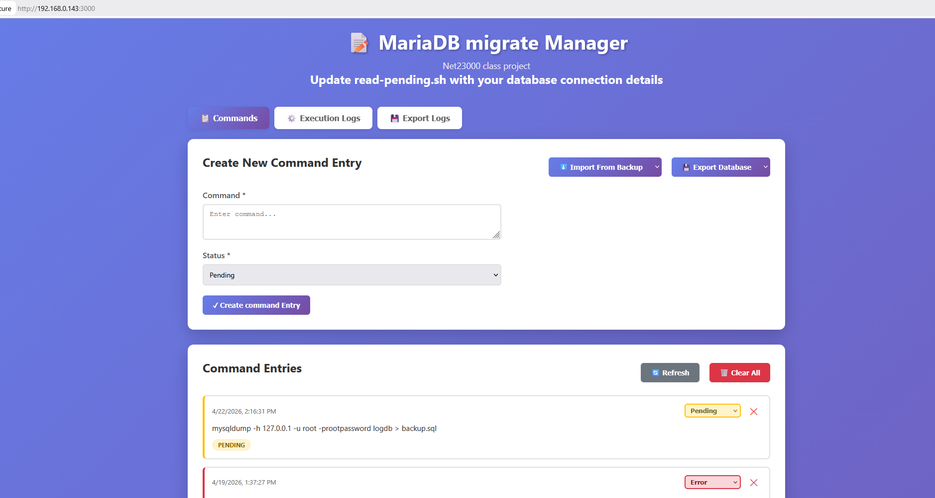
Start start-engine.sh and confirm backup.sql file creation:
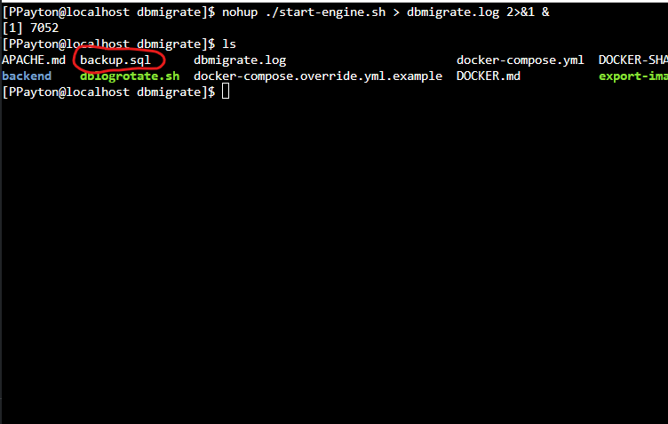
2.Create a shell script called backupdb.sh to backup logdb to file with timestamp:
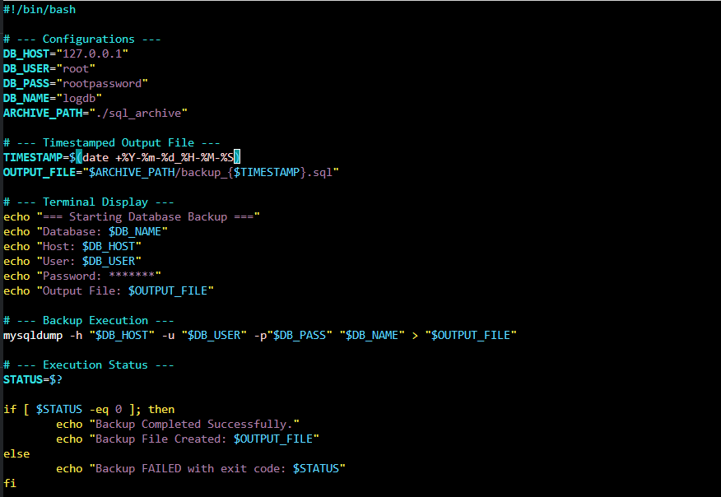
Test run:
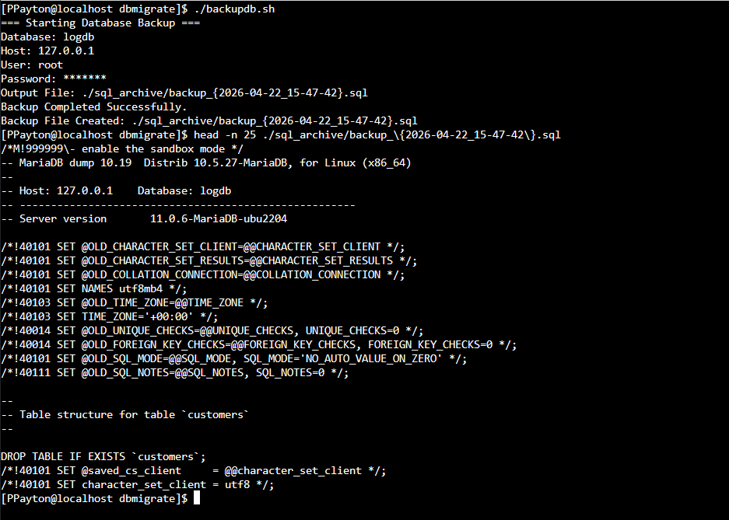
3. Issue backupdb.sh command from frontend:
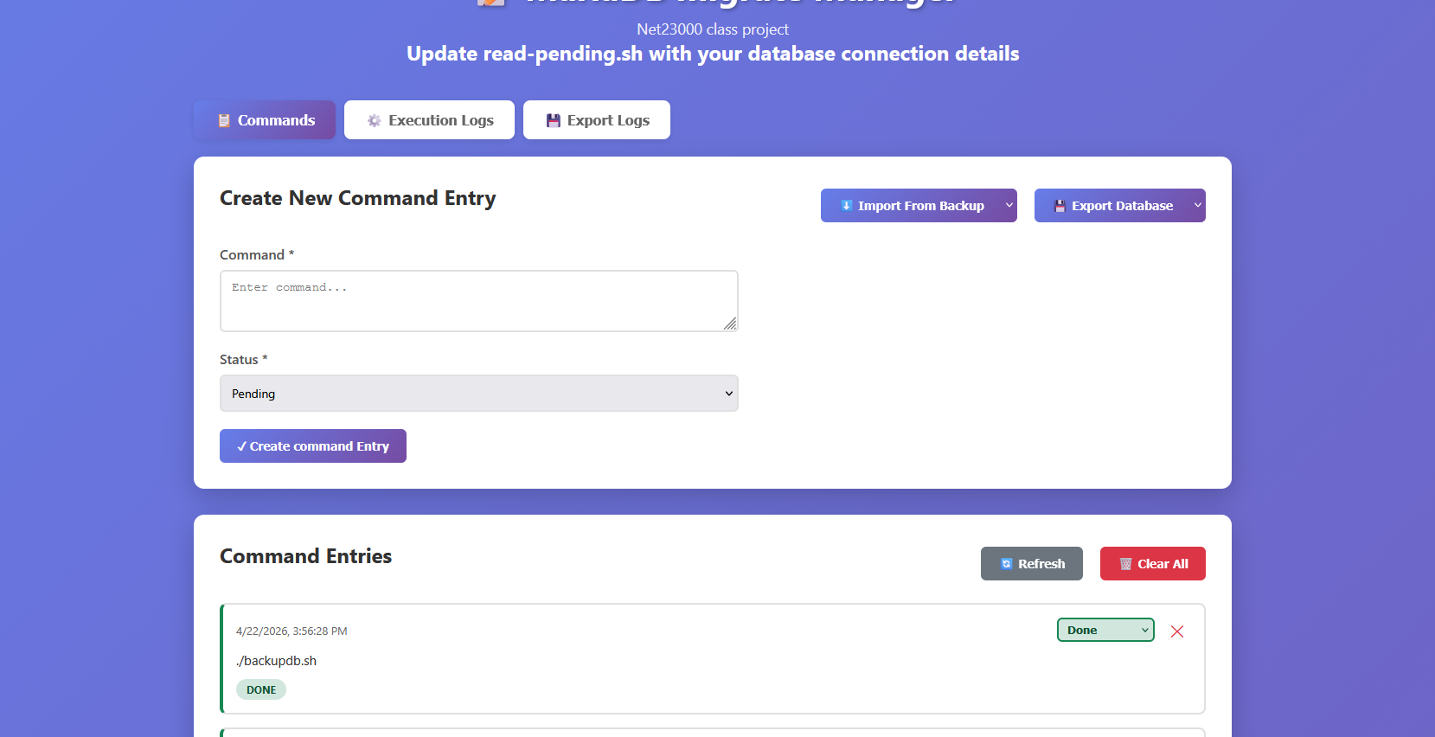
Confirm file creation:
